# Kericho District Hospital IQCare Database Findings

**Executive summary**

Kericho District Hospital has been using IQCare EMR System to manage CCC patient data. The facility recently contacted Palladium for support as they had concerns over the monthly reports being generated from the system.

This report highlights gaps in the database that could explain why the facility has discrepancies in their monthly reports.

**Findings**

|  |  |  |  |  |  |
| --- | --- | --- | --- | --- | --- |
| **No** | **Check Purpose** | **Observations** | **Possible cause** | **Impact** | **Solution** |
| 1 | Identify integrity of patient records in the facility source database here after referred to as “facility live database” | The facility live database has **15340** patient records that have at least 2 instances of the patient.  Refer to **query 1** in the appendix section | Previous migration script applied multiple times on the facility live database | Patient clinical records fragmented across the multiple instances of each patient. | We need to approach the KDH database migration with a different workflow.   * 1. Restore backup prior to attempted migration here after referred to as Original Database   2. Record last encounter date for each patient in Original Database   3. Apply new migration script on Original database   4. Identify new Patients in facility live database   5. Migrate patients identified in (d) and clinical records   6. Apply migration test plan   7. Site to sign-off |
| 2 | Identify integrity of patient registration dates records in the facility source database here after referred to as “facility live database” | **553** Patients with the same CCC number have different registration into CCC dates  Refer to **query 2** in the appendix section | Previous migration script applied multiple times on the facility live database | Patient falls into different enrolment periods. | * 1. Produce list of patients with different registration dates.   2. Facility with support from WRP to correct using dates in patient file |
| 3 | Identify integrity of patient start art dates records in the facility source database here after referred to as “facility live database” | **8493** Patients with the same CCC number have different ART start dates  Refer to **query 3** in the appendix section | Previous migration script applied multiple times on the facility live database | Patient falls into multiple cohorts. | 1. Produce list of patients in multiple cohorts 2. Facility with support from WRP to correct using dates in patient file |
| 4 | Identify patients in care without Pharmacy dispense records | **8274** Patients records with drug orders and no dispense data  Refer to **query 4** in the appendix section | Dispense data not entered into EMR | Inaccurate calculations of numbers in care and on ART | 1. Produce list of patients with no dispense data 2. Facility with support from WRP to correct using dates in patient file |
| 5 | Identify integrity of patient pharmacy data in the facility source database here after referred to as “facility live database” | Patient pharmacy records entered on different patient identifiers following the duplication of patients  A CCC number '148317769' was randomly selected  Refer to **query 5** in the appendix section | Pharmacy entries were done on different patients given the CCC number is duplicated | Incomplete history of patient data because it’s fragmented across different patients. | 1. Resolve the patient duplication as described on check purpose **a** above 2. Facility with support from WRP to correct using data from patient file |
| 6 | Identify integrity of patient laboratory data in the facility source database here after referred to as “facility live database” | Patient lab records entered on different patient identifiers following the duplication of patients  A CCC number '148317769' was randomly selected  Refer to **query 6** in the appendix section | Laboratory entries were done on different patients given the CCC number is duplicated. | Incomplete history of patient data because it’s fragmented across different patients. | 1. Resolve the patient duplication as described on check purpose **a** above 2. Facility with support from WRP to correct using data from patient file |

**Appendix**

1. **Query**: SELECT

PatientEnrollmentID, COUNT(*) as 'Number of records'

FROM

mst_Patient

GROUP BY

PatientEnrollmentID

HAVING

COUNT(*) > 1

**Results**:

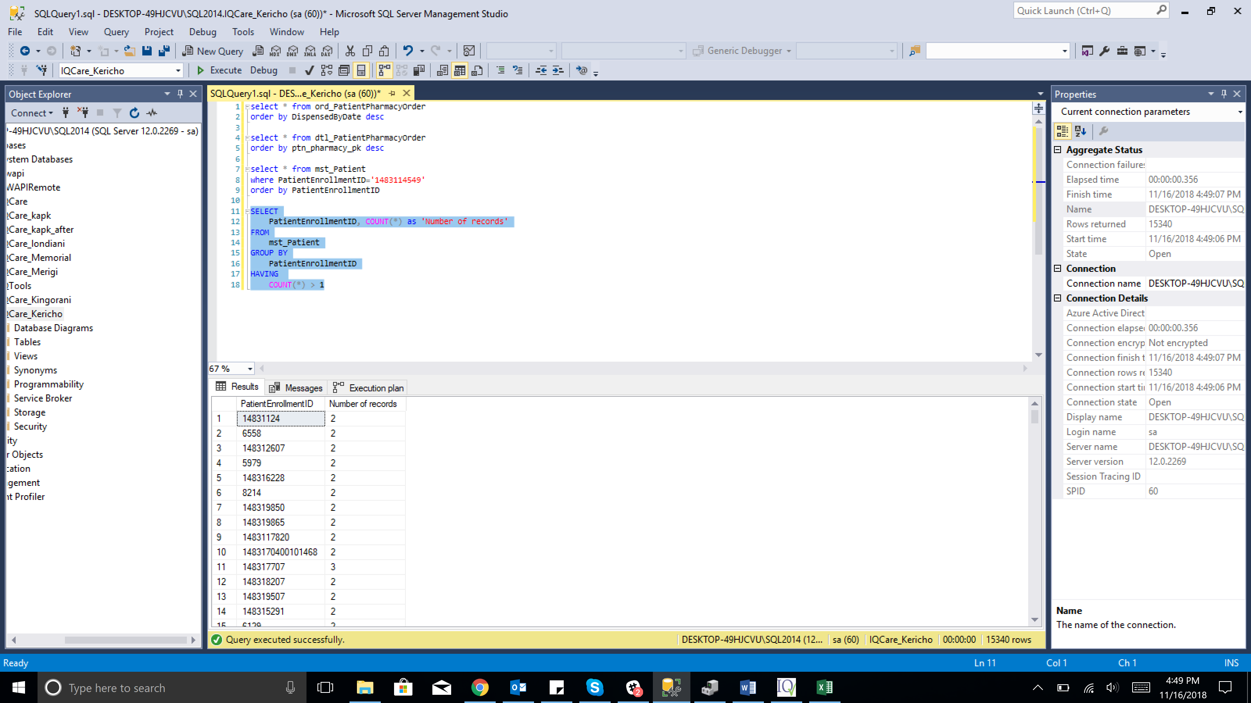

1. **Query:** ;with dup as(

Select PatientEnrollmentID, CASE WHEN min(CASE WHEN RegistrationDate IS NULL THEN 1 ELSE 0 END) = 0 THEN min(RegistrationDate) END as minregdate

, CASE WHEN MAX(CASE WHEN RegistrationDate IS NULL THEN 1 ELSE 0 END) = 0 THEN MAX(RegistrationDate) END as maxregdate from mst_patient where DeleteFlag = 0 group by PatientEnrollmentID

)

select * from dup

where (minregdate <> maxregdate or minregdate is null or maxregdate is null)

and COALESCE(minregdate, maxregdate) is not null order by PatientEnrollmentID

**Results:**

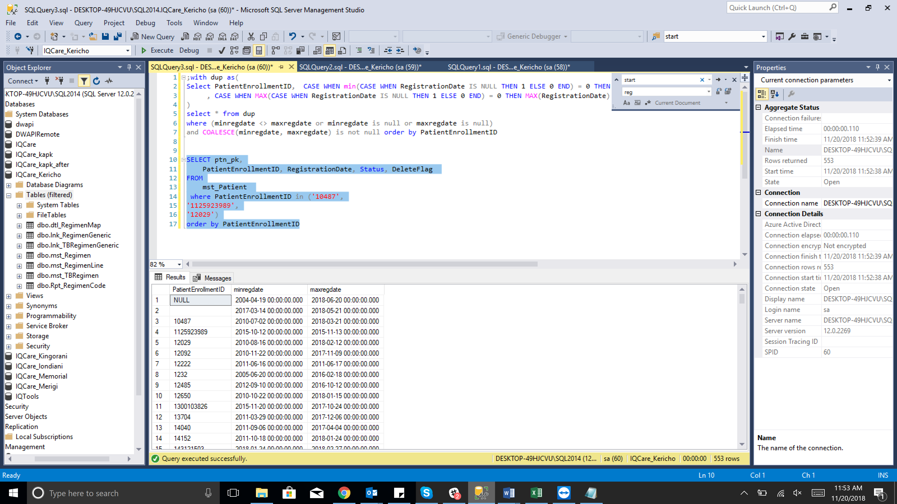

1. **Query:** ;with dup as(

Select PatientEnrollmentID, CASE WHEN min(CASE WHEN artstartdate IS NULL THEN 1 ELSE 0 END) = 0 THEN min(artstartdate) END as minstartdate

, CASE WHEN MAX(CASE WHEN artstartdate IS NULL THEN 1 ELSE 0 END) = 0 THEN MAX(artstartdate) END as maxstartdate from mst_patient where DeleteFlag = 0 group by PatientEnrollmentID

)

select * from dup

where (minstartdate <> maxstartdate or minstartdate is null or maxstartdate is null)

and COALESCE(minstartdate, maxstartdate) is not null order by PatientEnrollmentID

**Results:**

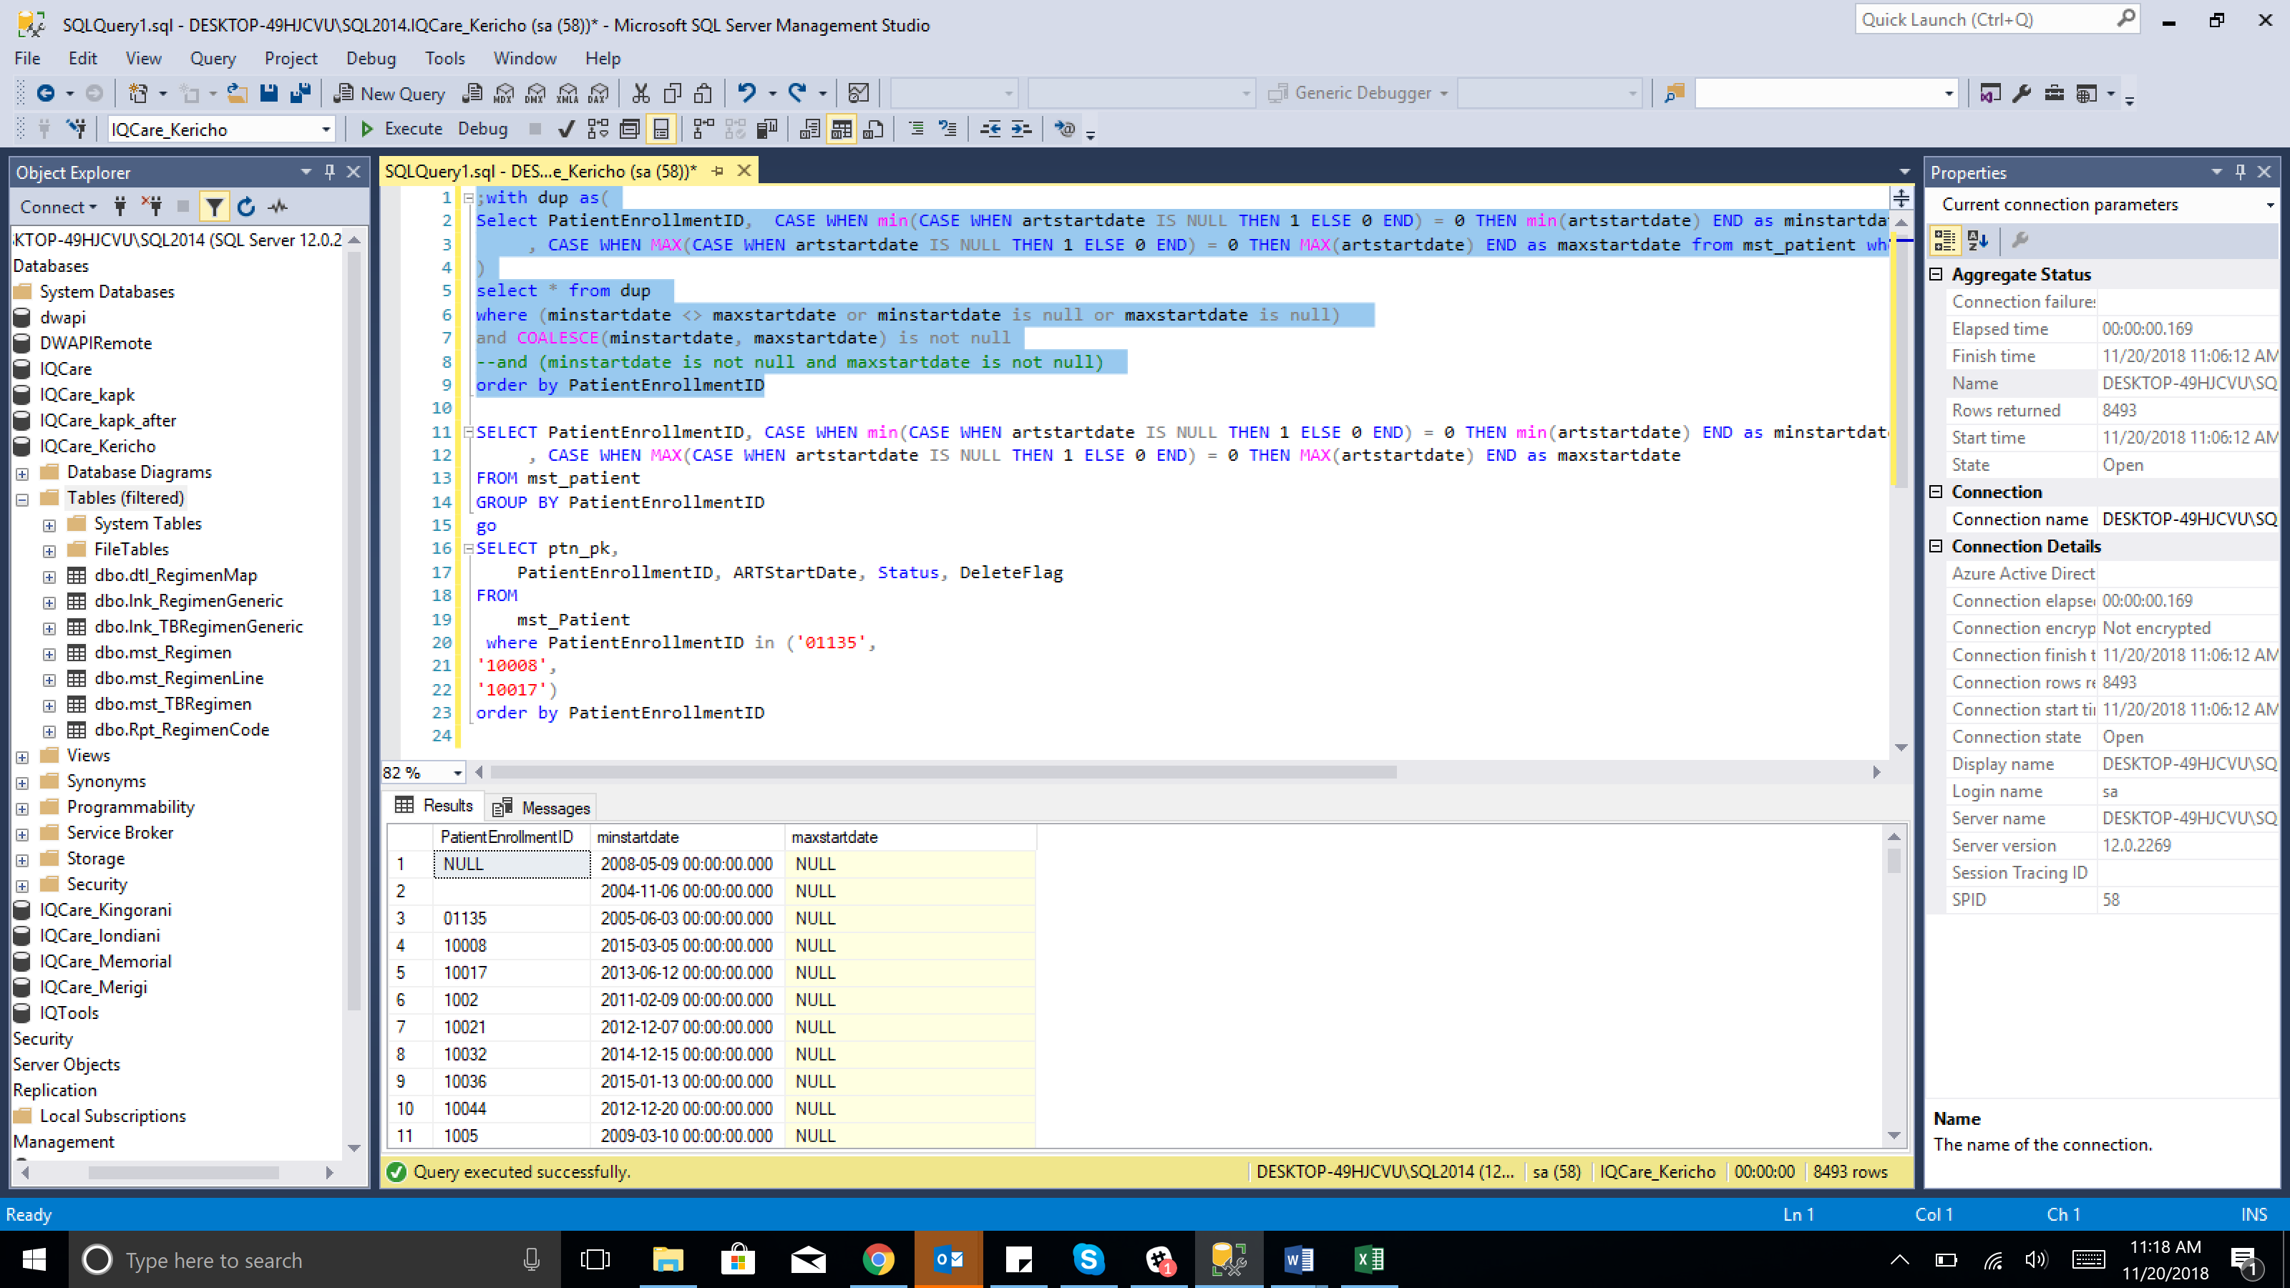

1. **Query:** select distinct ptn_pharmacy_pk from ord_PatientPharmacyOrder

where ptn_pharmacy_pk not in (select ptn_pharmacy_pk from dtl_PatientPharmacyOrder)

**Results:**

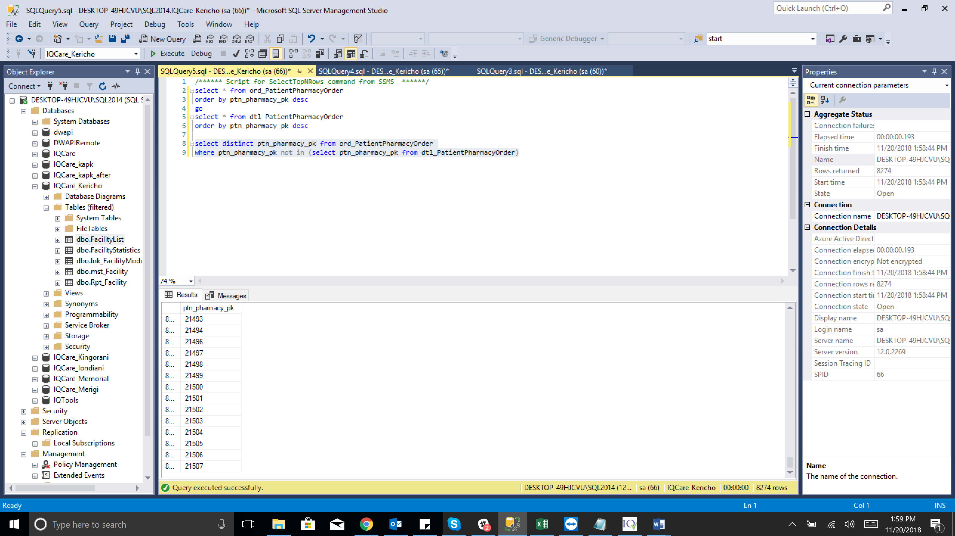

1. **Query:** select * from mst_Patient where PatientEnrollmentID='148317769'

go

select * from ord_PatientPharmacyOrder

where Ptn_Pk in (7029,25398)

**Results:**

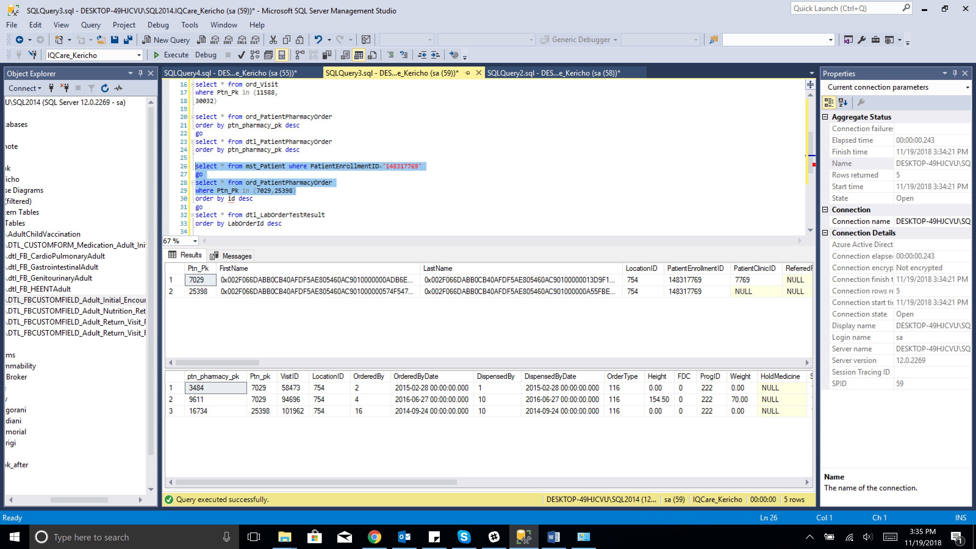

1. **Query:** select * from mst_Patient where PatientEnrollmentID='148317769'

go

select * from ord_LabOrder

where Ptn_Pk in (7029,25398)

**Results:**

